## horizontal line



ProjectOS Algorithms Name

A MOBILE APPLICATION FOR VISUALIZING OPERATING SYSTEM ALGORITHMS

**─**

# Full Team Member List

## Team 26 ( Disk Scheduling Project )

Devansh Shah 19BCP027

Dwireph Parmar 19BCP041

Geet Sharma 19BCP042

Harshal Shah 19BCP049

Kohav Yadav 19BCP069

## Team 31 ( Page Replacement Project )

Nisarg Koradia 19BCP088

Shashank Kumar 19BCP120

Aditya Kishtawal 19BCP147

## Team 32 ( Deadlock and Concurrency Project )

Mustafa Africawala 19BCP083

Parth Raval 19BCP090

Pathik Viramgama 19BCP093

# Overview

Concurrency And Deadlock application which has been merged as a part of ProjectOS mobile application in order to prepare a more complete application for OS

algorithms visualization, can run and visualize the various Concurrency and Deadlock algorithms.

# Technical Specifications

**Language:** Flutter(Dart)

**IDE:** Android Studio or VS code

**Getting your Windows Machine ready:**

1) Installation of **Flutter**

1.1) System requirements:

To install and run Flutter, your development environment must meet these minimum

**Requirements:**

*Operating Systems:*

* Windows 7 SP1 or later (64-bit), x86-64 based

*Disk Space:*

* 1.32 GB (does not include disk space for IDE/tools).

*Tools:*

* Flutter depends on these tools being available in your environment.
* Windows PowerShell 5.0 or newer
* Git for Windows 2.x, with the Use Git from the Windows Command Prompt option. If Git for Windows is already installed, make sure you can run git commands from the command prompt or PowerShell.

1.2) Download **Flutter SDK:**

1. Download the following installation bundle to get the latest stable release of the Flutter SDK: flutter_windows_2.0.5-stable.zip
2. Extract the zip file and place the contained flutter in the desired installation location for the Flutter SDK (for example, C:\src\flutter).

1.3) Update your path

If you wish to run Flutter commands in the regular Windows console, take these steps to add Flutter to the PATH environment variable:

* From the Start search bar, enter ‘env’ and select **Edit environment variables for your account.**
* Under **User variables** check if there is an entry called **Path**:
* If the entry exists, append the full path to flutter\bin using ; as a separator from existing values.
* If the entry doesn’t exist, create a new user variable named Path with the full path to flutter\bin as its value.
* You have to close and reopen any existing console windows for these changes to take effect.

1.4) Run **flutter doctor:**

From a console window that has the Flutter directory in the path (see above), run the following command to see if there are any platform dependencies you need to complete the setup:

#### **C:\src\flutter>flutter doctor**

This command checks your environment and displays a report of the status of your Flutter installation. Check the output carefully for other software you might need to install or further tasks to perform (shown in **bold** text).

For example:

#### **[-] Android toolchain - develop for Android devices**

#### **• Android SDK at D:\Android\sdk**

✗ **Android SDK is missing command line tools; download from https://goo.gl/XxQghQ • Try re-installing or updating your Android SDK,**

**visit https://flutter.dev/setup/#android-setup for detailed instructions.**

1.5) Install **Android Studio**

1. Download and install Android Studio.
2. Start Android Studio, and go through the ‘Android Studio Setup Wizard’. This installs the latest Android SDK, Android SDK Command-line Tools, and Android SDK Build-Tools, which are required by Flutter when developing for Android.

1.6) Set up your **Android device**

To prepare to run and test your Flutter app on an Android device, you need an Android device running Android 4.1 (API level 16) or higher.

1. Enable **Developer options** and **USB debugging** on your device. Detailed instructions are available in the Android documentation.
2. Windows-only: Install the Google USB Driver.
3. Using a USB cable, plug your phone into your computer. If prompted on your device, authorize your computer to access your device.
4. In the terminal, run the flutter devices command to verify that Flutter recognizes your connected Android device. By default, Flutter uses the version of the Android SDK where your adb tool is based. If you want Flutter to use a different installation of the Android SDK, you must set the ANDROID_SDK_ROOT environment variable to that installation directory.

1.7) Set up the **Android emulator:**

To prepare to run and test your Flutter app on the Android emulator, follow these steps:

1. Enable VM acceleration on your machine.
2. Launch **Android Studio**, click the **AVD Manager** icon, and select **Create Virtual Device…** ○ In older versions of Android Studio, you should instead launch **Android Studio > Tools > Android > AVD Manager** and select **Create Virtual Device….** (The Android submenu is only present when inside an Android project.)

* If you do not have a project open, you can choose Configure > AVD Manager and select Create Virtual Device…

1. Choose a device definition and select **Next**.
2. Select one or more system images for the Android versions you want to emulate, and select **Next**. An *x86* or *x86_64* image is recommended.
3. Under Emulated Performance, select **Hardware - GLES 2.0** to enable hardware acceleration. vi. Verify the AVD configuration is correct, and select **Finish**.

For details on the above steps, see Managing AVDs.

1. In Android Virtual Device Manager, click **Run** in the toolbar. The emulator starts up and displays the default canvas for your selected OS version and device.

2) Set up an **editor**(using VS Code)

2.1) Install VS Code:

VS Code is a lightweight editor with Flutter app execution and debug support.

2.2) Install the **Flutter and Dart plugins**:

### **Start VS Code.**

### Invoke View > Command Palette….

### Type “install”, and select Extensions: Install Extensions.

### Type “flutter” in the extensions search field, select Flutter in the list, and click

### Install. This also installs the required Dart plugin.

2.3) Validate your setup with flutter doctor:

1. Invoke View > Command Palette….
2. Type “doctor”, and select the Flutter: Run Flutter Doctor.
3. Review the output in the OUTPUT pane for any issues. Make sure to select Flutter from the dropdown in the different Output Options.

For more details and to solve some error you can visit to Flutter Installation

**How to run?**

**Method 1:**

1. Download .apk file for ProjectOS
2. Install this .apk file in your Android Device and you can run Concurrency and Deadlock Algorithms directly on you Android Device

**Method 2:**

Follow the commands to run this application:

1. Go to GitHub to download the main files for the project.
2. Go to the merged branch.
3. Click on **Code** as shown below.

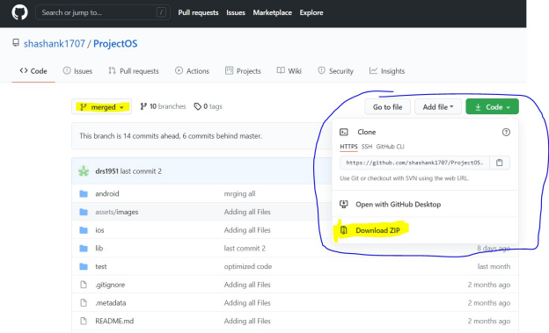

1. Click **Download ZIP** to download the Zip folder for our project.

### **Extract file contents of Zip folder to any desired location.**

1. Now, open the terminal to move to the Flutter Project location using cd command.
2. Once you are in project’s directory use command $ **flutter pub get**
3. **After completing all the above steps you can open VS Code and open your Project.**

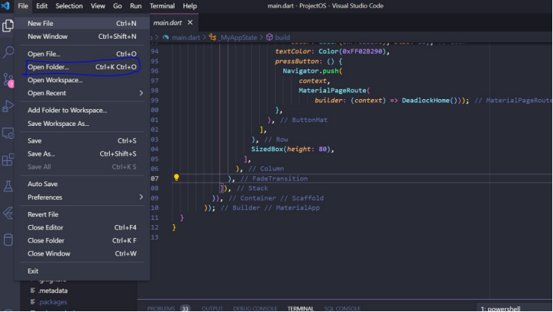

1. To open your project click **File > Open Folder> Flutter Project. Now, our project is completely loaded your machine**
2. **By clicking on Explorer -> ProjectOS you can see all the files related to this project and using editor you can edit code as you wish.**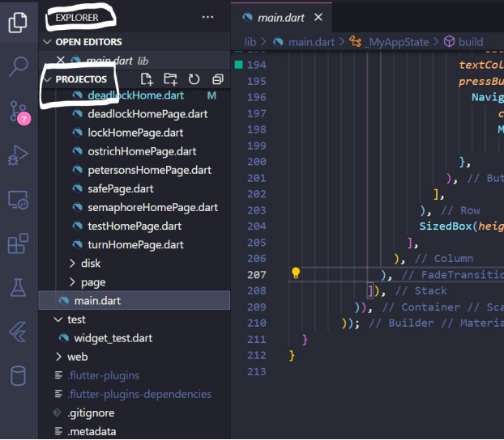
3. **To run this project, go to Run -> Run Without Debugging for a quicker launch.**

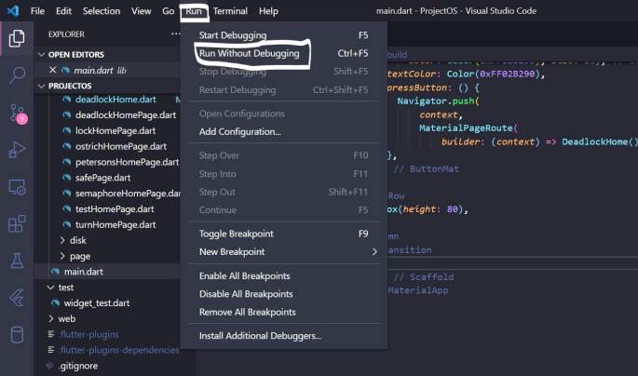

1. **The project will launch on the selected emulator.**

# 

# 

# 

# 

# 

# How to use it?

### **We have uploaded a working video of the project on Youtube which will give you all the information on how to use the Concurrency and Deadlock algorithms and how to take benefit of all the features provided.**

Links of the video:

Page Replacement Algorithm:

<https://youtu.be/xw6zmtpAFDM>

Deadlock And Concurrency Algorithm:

<https://youtu.be/CvEuzlaQ_wg>

Disk Scheduling Algorithm:

<https://youtu.be/yuRvvWzmus4>